Easy and Affordable Pancake Recipe for Pancake Tuesday

Pancake Tuesday, also known as Shrove Tuesday, is a day celebrated around the world with delicious pancakes before the fasting period of Lent begins. Whether you're observing this tradition or simply craving a tasty breakfast, this easy and cost-effective pancake recipe is perfect for anyone looking to whip up a batch of fluffy pancakes without breaking the bank. With simple ingredients and straightforward instructions, you'll be flipping perfect pancakes in no time!

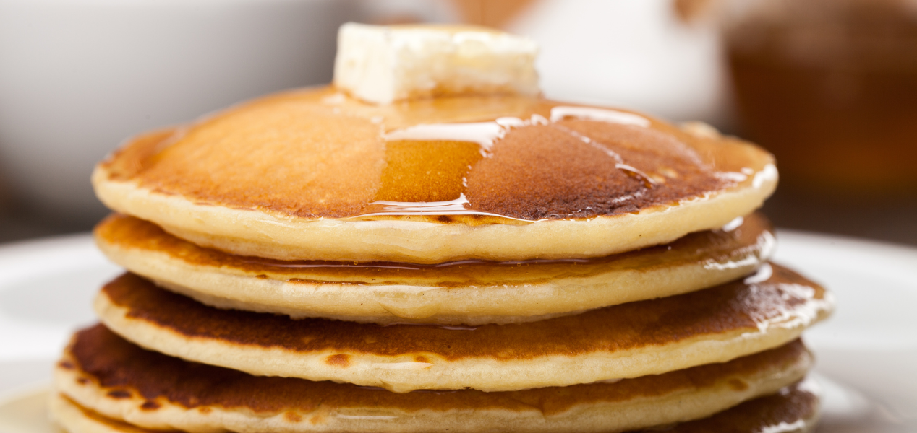

Ingredients:
- 1 cup all-purpose flour
- 1 tablespoon sugar (optional)
- 2 teaspoons baking powder
- 1/4 teaspoon salt
- 1 cup milk
- 1 egg
- 2 tablespoons vegetable oil or melted butter
- Additional butter or oil for cooking

Instructions:
- In a mixing bowl, whisk together the flour, sugar (if using), baking powder, and salt until well combined.
- In a separate bowl, whisk together the milk, egg, and vegetable oil or melted butter until smooth.
- Pour the wet ingredients into the dry ingredients and stir until just combined. It's okay if the batter is slightly lumpy.
- Heat a non-stick skillet or griddle over medium heat and add a small amount of butter or oil to coat the surface.
- Once the skillet is hot, pour a small amount of batter onto the skillet to form pancakes of your desired size. Cook until bubbles form on the surface of the pancake and the edges begin to look set, about 2-3 minutes.
- Carefully flip the pancakes with a spatula and cook for an additional 1-2 minutes, or until golden brown and cooked through.
- Remove the pancakes from the skillet and keep warm while you cook the remaining batter. You may need to add more butter or oil to the skillet between batches.
- Serve the pancakes warm with your favorite toppings, such as maple syrup, fresh fruit, or whipped cream.
Yield: This recipe makes approximately 8-10 pancakes, serving 4-5 people.

With this easy and affordable pancake recipe, you can enjoy delicious homemade pancakes on Pancake Tuesday or any day of the year. Whether you're serving a crowd or just cooking for yourself, these fluffy pancakes are sure to be a hit. So grab your ingredients and get flipping - breakfast is served!

